15.BLOOD BANK REGISTRATION SYSTEM

ACTIVITY DIAGRAM

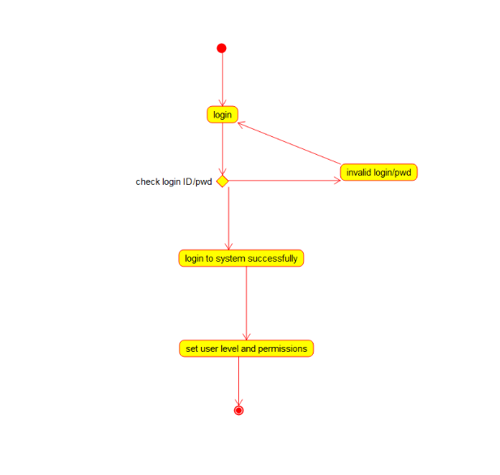

COLLABORATION DIAGRAM

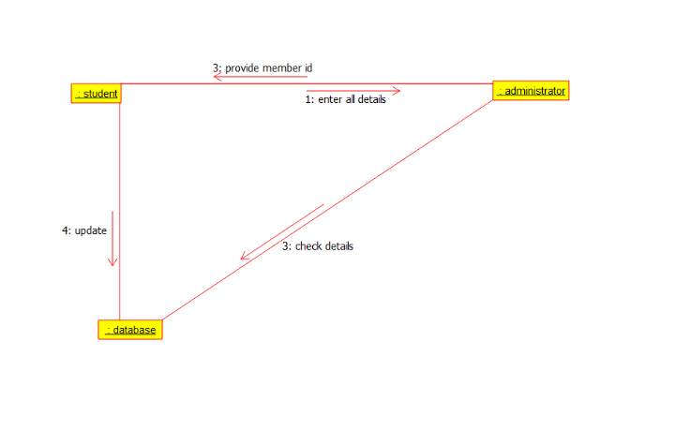

SEQUENCE DIAGRAM

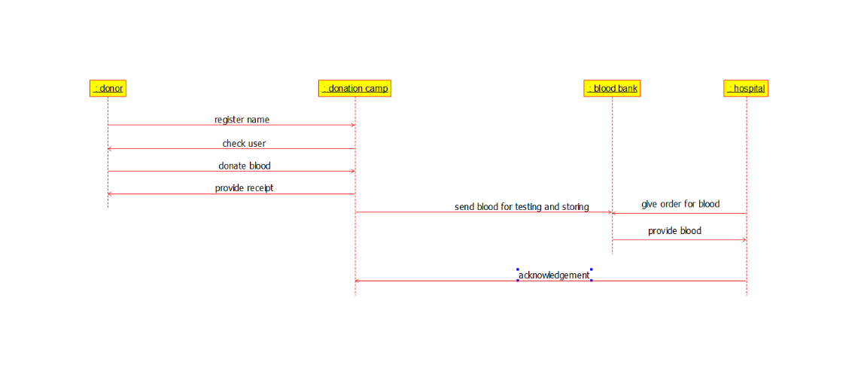

DEPLOYMENT DIAGRAM

